10.1 R Tutorial 6

Introduction to Computational Science:
Modeling and Simulation for the Sciences, 2nd Edition
Angela B. Shiflet and George W. Shiflet
Wofford College
© 2014 by Princeton University Press
Introduction
We recommend that you work through this tutorial with a copy of R, answering all Quick Review Questions.
The prerequisites to this tutorial are R Tutorials 1-5. Tutorial 6 introduces the following functions and options, which simulations of this chapter employ: joining arrays, size of an array, visualizing a rectangular array, multidimensional arrays, element-by-element comparisons of arrays, finding where a condition is true, and obtaining the closest integer less than or equal to a floating point number. Module 10.4, "Movement of Ants⎯Taking the Right Steps," and Module 10.5, "Biofilms⎯United They Stand, Divided They Colonize," use finding where a condition is true, while Module 10.2, "Diffusion: Overcoming Differences," and Module 10.3, "Spreading of Fire," do not.
Joining Arrays
By specifying sequences of rows and columns, we can obtain a subarray. Similarly, joining several arrays of the same size, we can obtain a matrix. For the arrays array1, array2, ... of the same size, the following general form returns a row binding by placing the rows in a matrix:

rbind(array1, array2, ... )

The command binding three arrays of size four

rbind(c(1, 2, 3, 3), c(4, 5, 6, 6), c(7, 8, 9, 9))

returns the following 3 × 4 matrix:

[,1] [,2] [,3] [,4]
[1,] 1 4 7 10
[2,] 2 5 8 11
[3,] 3 6 9 12

Column binding, cbind, places the arrays in columns. Thus, the command

rbind(c(1, 2, 3, 3), c(4, 5, 6, 6), c(7, 8, 9, 9))
returns the following 4 × 3 matrix:

[,1] [,2] [,3]
[1,] 1 4 7
[2,] 2 5 8
[3,] 3 6 9
[4,] 3 6 9
Quick Review Question 1 Start a new Script. In opening comments, have "R Tutorial 6 Answers" and your name. Save the file under the name RCTTutorial6Ans.m. In the file, preface this and all subsequent Quick Review Questions with a comment that has "## QRQ" and the question number, such as follows:

## QRQ 1 a
Consider the following rectangular array mat:

mat = matrix(1:9, nrow=3)

a. Give the command to return the last column. Thus, the returned column vector is c(7, 8, 9).
b. Write a command to return a rectangular array that is equal to mat except the last column of mat appears as the first and last column of the new array. Thus, the new array has four columns, and its second, third, and fourth columns are equal to the columns of mat. In your command, do not type specific elements of mat but commands to take a subarray and join it to mat.
Quick Review Question 2 Consider the array mat in Quick Review Question 1.
a. Give the command to return the last row. Thus, the returned vector is c(3, 6, 9).
b. Write a command to return a rectangular array that is equal to mat except the last row of mat appears as the first and last row of the new array. Thus, the new array has four rows, and its second, third, and fourth rows are equal to the rows of mat. Recall that a semicolon separates rows. In your command, do not type specific elements of mat but commands to take a subarray and attach it to mat.
Quick Review Question 3 Consider the array mat in Quick Review Question 1.
a. Write a statement to assign to extendRows the array with five rows: the last row of mat, the rows of mat, and the first row of mat. Thus, for mat having three rows, the new array has five rows.
b. Write a statement to assign to extendCols the array with five columns: the last column of extendRows from Part a, the columns of extendRows, and the first column of extendRows. Thus, for extendRows having three columns, the new array has five columns. For mat, the final result is the following 5-by-5 array:

[,1] [,2] [,3] [,4] [,5]
[1,] 9 3 6 9 3
[2,] 7 1 4 7 1
[3,] 8 2 5 8 2
[4,] 9 3 6 9 3
[5,] 7 1 4 7 1
Size
For generality in functions, it is sometimes useful to obtain an array's size, or the number of elements, in a particular dimension. By specifying the array and the dimension, the size function returns the corresponding number of elements. If the dimension is 1, the returned size is the number of rows; while a dimension of 2 results in a returned size equaling the number of columns. The following form using dim returns the number of rows and columns of matrix m:

dim(m)

Thus, the following command returns "5 3" indicating a matrix of 5 rows and 3 columns:

dim(extendRows)

Separately, nrow returns the number of rows and ncol returns the number of columns of a matrix:

nrow(extendRows)
ncol(extendRows)
Quick Review Question 4 Execute the following to assign to lst an array of all zeros that has at random between 5 and 15 rows and at random between 1 and 4 columns:

lst = matrix(rep(0), nrow = floor(runif(1, 5, 16)),
ncol = floor(runif(1, 1, 5)))

a. Using dim, display the number of rows and columns of lst.
b. Display the number of rows of lst.
c. Display the number of columns of lst.
Grid Graphics
Frequently, simulations involve evolving rectangular arrays of numbers, and pictorial
representations of these matrices can help scientists understand the information. The graphics function image represents such a grid with each cell being an index into a level of grey-scale or color map, which is an array of color values. The function colormap establishes the color map. The following command establishes a grey color map with five shades from black (index 1) to white (index 5):

col = grey(seq(0, 1, length = 5))

For example, the following segment generates a 4 × 3 array, randGrid, of random integer values from 1 through 5 and displays a visualization of the grid in black, white, and shades of grey with no axes () and with a box surrounding the graphics,:

randGrid = matrix(floor(runif(12, 1, 6)), ncol=3)
image(randGrid, col = grey(seq(0, 1, length = 5)), axes = FALSE)
box()

With randGrid as follows, Figure 1 shows the resulting graphics with 1 as index to black and 5 as index to white and with the graphics rotated counterclockwise, so that the last matrix column corresponds to the first image row:

[,1] [,2] [,3]
[1,] 5 4 1
[2,] 1 5 5
[3,] 2 5 4
[4,] 1 3 2
Figure 1 Visualization of grid in five shades, from black through shades of grey to white
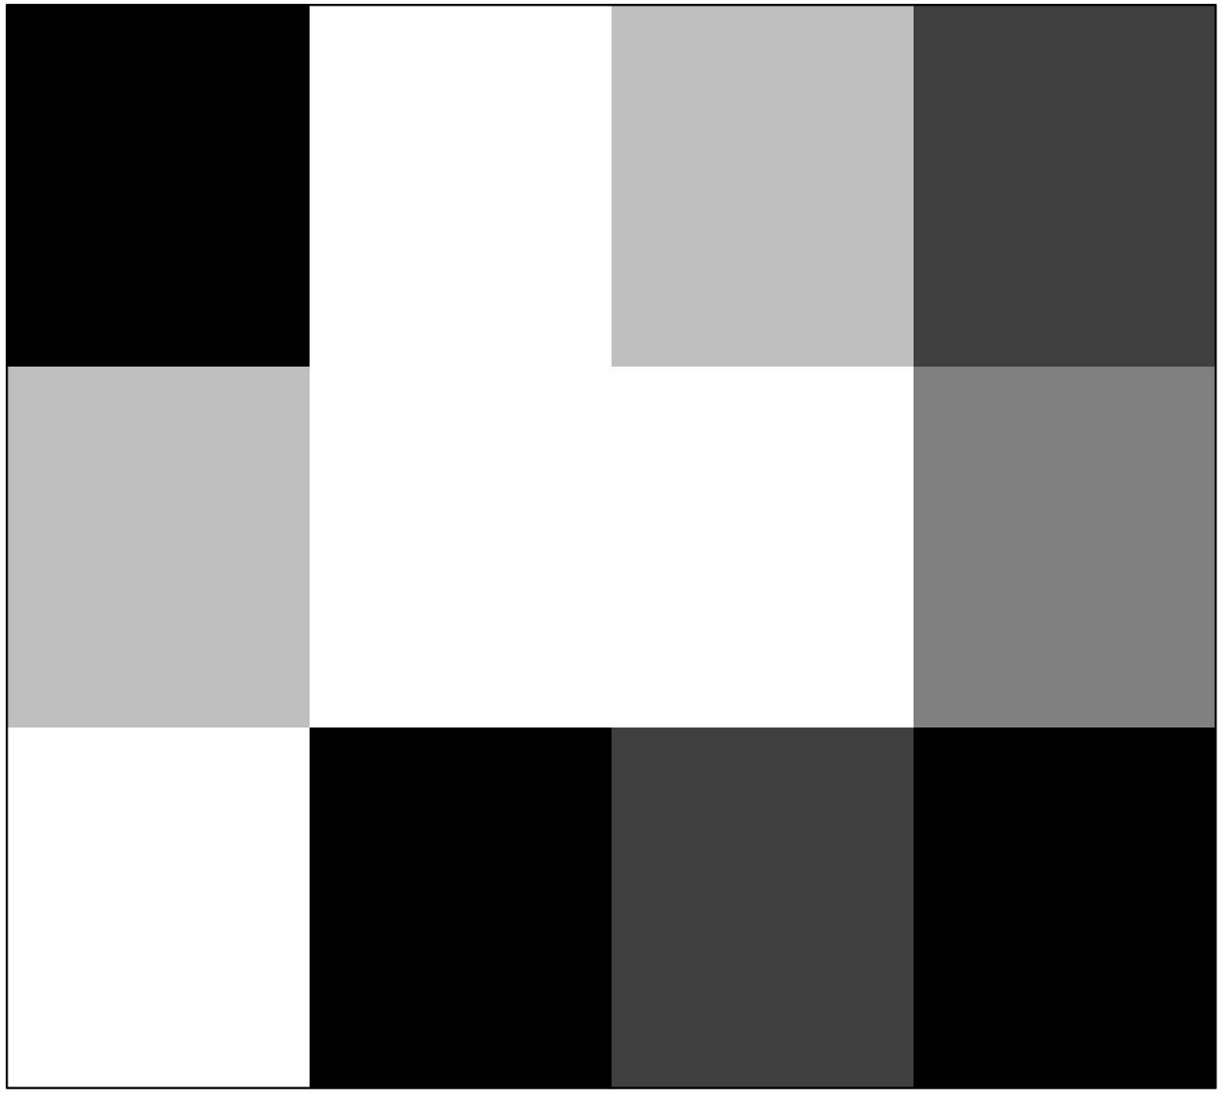

To elicit a proper scientific visualization, it is often helpful to define our own color map. Consider the following command assigns to matEx a 4-by-4 array zeros and ones.

matEx = matrix(c(0, 0, 1, 0, 0, 1, 0, 0, 1, 0, 0, 0, 1, 1, 0, 0),
nrow = 4)

[,1] [,2] [,3] [,4]
[1,] 0 0 1 1
[2,] 0 1 0 1
[3,] 1 0 0 0
[4,] 0 0 0 0

To visualize the grid with yellow representing 0 and forest green, 1, we first establish the color map as an array with two rows. Yellow has red-green-blue (rgb) values of 1, 1, and 0, respectively, on the first row; and forest green has the three values 0.1, 0.75, and 0.2 on the second row. After defining, we establish map as the color map, as follows:

map = c(rgb(1, 1, 0), rgb(0.1, 0.75, 0.2))

Because the row index begins with 1, not 0, we add 1 to every value of matEx and generate an image of the resulting grid of ones and twos, as follows:

image(matEx, col = map, axes = FALSE)
box()

Figure 2 displays the resulting visualization.
Figure 2 Visualization of array of zeros and ones with color map having yellow and green, respectively
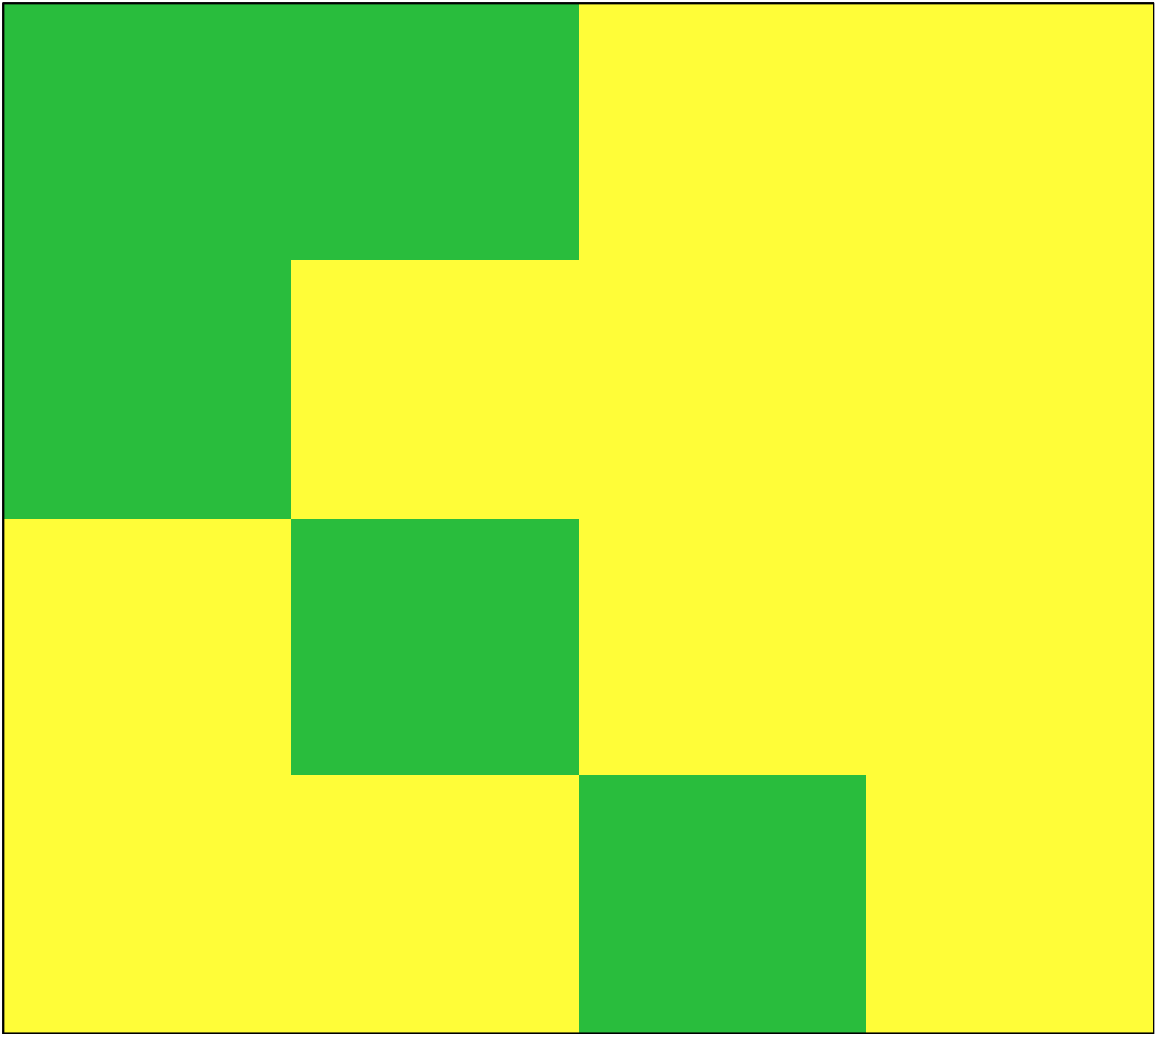
Quick Review Question 5
a. Generate a 10-by-10 matrix, randMat, of random integers between 1 and 4, inclusively.
b. Visualize randMat in four shades of grey with no axes, surrounded by a box.
c. The following parts create a color map with shades of red and visualize randMat with this coloring scheme. Assign to map the RGB values for a shade of red with red values from 1/4 to 4/4 = 1 and blue and green values of zero.
d. Visualize randMat in 4 shades of red as a square with no axes.
Quick Review Question 6
a. Generate a 10-by-10 array, mc, of integers indicating the columns. For example, column four contains all fours.
b. Generate a color map of ten colors, where the first and second coordinates (amounts of red and green) each varying from 0 to 0.9 in steps of 0.1 and with the third coordinate being 0. Visualize mc using this color map.
Quick Review Question 7 Smooth out the display from Quick Review Question 6 with a 100-by-100 matrix mc2 and appropriately smaller step sizes.
Multidimensional Arrays
We have frequently employed one- and two-dimensional arrays. In this chapter, three- and even four-dimensional arrays, called multidimensional arrays, are useful for storing grids from multiple time steps. For example, suppose data for one time step is in a 20-by-20 array, or grid, of integers. Each time step of the simulation updates the grid values. To store all the grid information for later analysis, processing, or visualization, we can use a three-dimensional array, say gridList. The first index gives the row; the second, the column; and the third index specifies the page. The initial grid is the 20-by-20 array gridList[, , 1], and gridList[, , 2] stores the grid for time step 1.
xxxQuick Review Question 8 xxx assign mc to mcList and then rbind in a for loop
a. Make mcList a 10-by-10-by-6 array of zeros.
b. Assign mc from Quick Review Question 6 to the first page of mcList.
c. Using a for loop with index i varying from 1 to 5, store the results of adding i to mc in subsequent pages of mcList. Thus, Page 2 of mcList will contain mc + 1, and Page 6 of mcList will contain mc + 5.
d. Generate color map of fifteen colors, where the first and second coordinates each varying from 0 to 14/15 in steps of 1/15 and the third coordinate is 0.
e. Produce an animation of the pages of mcList using this color map and a movie. After generating a graphics for one frame, at the end of the for loop, pause the animation and then flush graphics buffer, or memory area, as follows:

Sys.sleep(0.1)
dev.flush()
Array Comparisons
We can employ the relational operators (<, >, <=, >=, ==, and ~=) to compare two numbers and for an element-by-element comparison of two arrays that have the same size. For the latter situation, the return value is a logical array of the same size with 1 appearing where a relationship is true and 0 where false. For example, consider the following vectors:

v1 = [3 6 5 9];
v2 = [2 8 7 4];

The expression v1 < v2 returns the vector [0 1 1 0] because only the middle two element-by-element inequalities, 6 < 8 and 5 < 7, are true.
If we compare an array with a number, R expands the number into an array of the same size. Thus, v1 == 5 performs the comparison v1 == [5 5 5 5], which returns [0 0 1 0] because 3 ≠ 5, 6 ≠ 5, 5 == 5, and 9 ≠ 5.
Quick Review Question 9
a. Generate and display a 3-by-3 array, ra, of random floating point numbers between 0 and 1.
b. Perform a comparison that returns a 3-by-3 logical array indicating the elements that are less than 0.5.
Position of a Pattern
The R function find identifies the locations in an array, expr, that are nonzero (true) with the following command form:

find(expr)

To find the locations of pattern, pattern, in an array, expr, we can employ the following command form:

find(expr == pattern)

The function returns a vector of indices. We can use these indices in further computations, such as finding corresponding values in two lists.
The following call to find returns a vector, [2 4 5], indicating the indices of 'b' in ['a' 'b' 'c' 'b' 'b']:

pos = find(['a' 'b' 'c' 'b' 'b'] == 'b')
Quick Review Question 10 Assign to ages a vector of 10 random integers with values between 21 and 23, inclusively. For example, ages might be a list of the ages of 10 patients. Then, using find, give a command to assign to pos21 a vector of the indices where 21 occurs.
Quick Review Question 11 Assign to weight a vector of 10 random integers between 100 and 250. For example, weight might store the weights of 10 patients. Using weight and pos21 from the previous Quick Review Question, write an expression to display the weights of the patients who are 21 years old.
Floor
To obtain an integer random number, we can apply the floor function to the computation. This function returns the largest integer less than or equal to an argument. Thus, floor(2.8)and floor(2) are both 2. This function is useful when we need an integer value, such as for a vector index, instead of a floating point number.

